Dear Patient,
Please find enclosed your Hereditary Cancer Testing Blood Kit to help determine if have an inherited genetic susceptibility to developing cancer and therefore, if you have an increased risk of developing cancer in your lifetime.
The only genes to be tested will be the cancer susceptibility genes listed on the hereditary cancer susceptibility gene panel that has been recommended for you.
This kit contains  123456789 | Name:  DOB:  Sample Date: | 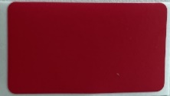 | 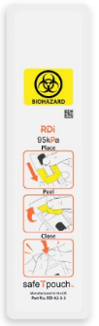
1 x Unique Barcode Label | 1x Patient Identifier Label | 1 x Tamper-proof Seal | 1 x Mailing Pouch
Instructions
Please take this kit to a phlebotomist to conduct a blood draw. This kit contains the relevant components to return the sample to the laboratory for testing after blood draw. This kit does NOT contain the collection tube; this must be provided by the phlebotomist.
Before taking the sample
- Write your first and last name, date of birth and sample date on the clearly marked Patient Identifier Label provided. Please be careful not to write over the barcode. Your sample may be at risk of rejection if we cannot identify who the sample belongs to.

Sampling Instructions for use by a medical professional
- Affix the Unique Barcode Label and the Patient Identifier Label to the blood collection tube
- Perform the blood collection in a K2 EDTA lavender-capped blood collection tube, a minimum of 3mL is required

After sampling
- After sampling, ensure the cap is securely closed and the blood is thoroughly missed by gentle inversion
- Place the labelled tube in the leakproof sample mailing pouch. Do not remove the absorbent strip. Seal the pouch by removing the peelable strip and pressing firmly on the adhesive area.
- Place the sealed pouch, containing the tube, in the outer rigid cardboard box.
- Seal the cardboard box with the Tamper-proof Seal. Ensure the prepaid return address and UN3373 label are both clearly visible.
- Keep the sample refrigerated at 4⁰C prior to posting. Post as soon as possible via Royal Mail, at a post box or your local Post Office branch.
NOTE: Samples received more than 14 days after sample collection are subject to rejection due to sample integrity concerns.
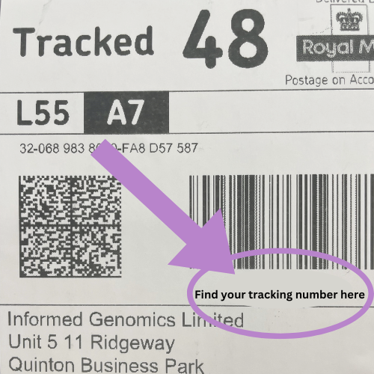
- Please make a note of your tracking and barcode for reference, indicated by the purple arrow below:
Sampling Details
Please record the following details below:
Sample Barcode
Sample Collection Date
Tracking Reference Number

Checklist
Please check that you have:
Added your name, date of birth and sample date to the tube
Sealed the box without covering any labels
Made a note of your tracking number and sample barcode.

Now you are ready to post your sample. Thank you for following our instructions.
For any queries relating to your sample, please contact our laboratory directly via email using testing@nonacus.com quoting your Sample Barcode and Tracking Reference Number.

Best wishes,
The Nonacus Clinical Services Team

